**MINI PROJECT REPORT ON**

**IMAGE CLASSIFICATION IN HEALTHCARE**

**Submitted in partial fulfillment of the requirement for the award of the degree of**

**BACHELOR OF TECHNOLOGY**

**IN**

**COMPUTER SCIENCE & ENGINEERING**

**Submitted by:**

**UNNATI RASTOGI 21022874**

***Under the Guidance of***

Ms. Ankita Nainwal

**Assistant Professor**



**Department of Computer Science and Engineering**

**Graphic Era (Deemed to be University)**

**Dehradun, Uttarakhand**

**2023-24**



**CANDIDATE’S DECLARATION**

I hereby certify that the work which is being presented in the project entitled **“Image Classification In Healthcare”** in partial fulfillment of the requirements for the award of the Degree of Bachelor of Technology in Computer Science and Engineering in the Department of Computer Science and Engineering of the Graphic Era (Deemed to be University), Dehradun shall be carried out by the undersigned under the supervision of

**Ms. Ankita Nainwal,**  Department of Computer Science and Engineering, Graphic Era (Deemed to be University), Dehradun.

Unnati Rastogi 21022874

**Table of Contents**

|  |  |  |
| --- | --- | --- |
| **Chapter No.** | **Description** | **Page No.** |
| Chapter 1 | Introduction | **4** |
| Chapter 2 | Literature Survey | **6** |
| Chapter 3 | Methodology | **8** |
| Chapter 4 | Result and Discussion | **12** |
| Chapter 5 | Conclusion and Future Work | **13** |
|  | References |  |

**Chapter 1**

**Introduction**

* 1. **Introduction**

Introduction to Image Classification in Healthcare:

In healthcare sector, the combination of advanced technologies with medical procedures and treatment methods had caused a big positive impact on its overall functioning. One such transformative technology is image classification, a powerful tool that is used to analyze and interpret medical images. Image classification in healthcare involves the automated categorization of medical images, such as X-rays, MRIs, CT scans, and histopathological slides, to aid healthcare professionals in accurate and efficient diagnosis.

This approach has the great potential which can enhance the speed and precision of medical image interpretation, overall leading to improved patient outcomes. By applying the machine learning algorithms and deep neural networks, image classification systems can learn patterns and features from large datasets, enabling them to identify precise abnormalities or anomalies that may go unnoticed by the human eye.

The applications of image classification in healthcare are diverse, which detect diseases and conditions and then gives personalized treatment plans. It plays a crucial role in areas like radiology, pathology, and dermatology, where meteoric and accurate diagnosis is crucial. Additionally, image classification can contribute to the optimization of workflow in healthcare by reducing the burden on healthcare professionals and fostering a more efficient healthcare system.

While Image classification in healthcare holds great promise for faster and more precise diagnoses, certain challenges like data privacy, interpretability and ethical considerations must be carefully addressed to ensure responsible implementation. As technology progresses, the integration of image classification has the potential to revolutionize of medical imaging, paving the way for future.

Some advantages of Image Classification in Healthcare are-

1. **Early Detection and Diagnosis:**

In healthcare, image classification is really good at spotting and figuring out different health issues early on. It looks at medical pictures super carefully and can find the signs of diseases. This helps make sure patient get better treatment and have better results.

**2.Customized Treatment Plans:**

Doctors can use special software to look at pictures of a patient’s condition and

learn specific things about it. This helps them give treatments that are just right for

each person, making the results of treatment better.

**3.Enhanced Radiology Practices:**

In radiology, using image classification tech is a big help. It means that machines

can look at X-rays and CT scans and understand them without a person having to do

it all manually. This makes things easier for the radiologists, as they can spend more

time on the tricky cases and get things done faster.

**4. Research and Development:**

Using image classification in healthcare helps researchers study big sets of data.

They can find new patterns and connections that might help them understand

diseases better.

**5. Ongoing Technological Advancements:**

Machine learning and artificial intelligence are getting better and better, making

image classification in healthcare improve a lot. By using new and better

algorithms, improved models, and trying out new ways of taking images, these

systems are expected to do even more amazing things in the future.

**6. Giving priority and streamlined sorting:**

Image classification makes it easier to sort through medical images, figuring out

which cases need quick attention. This really helps healthcare work go more

smoothly because important cases get dealt with fast, making patient care

quicker and reducing waiting times.

**7. Automatic Discovery of Medical Issues:**

Image classification systems can automatically highlight irregularities or problems

in medical images, even ones that might be small or easy to miss. This proactive

approach helps spot unexpected findings early, encouraging more investigation

and lowering the chance of missing important details.

**Chapter 2**

**Literature Survey**

**2.1 Literature Survey**

* Jones, Emily R., et al. "Image Classification Techniques for Early Disease Detection: A Survey." IEEE Transactions on Biomedical Engineering, vol. 35, no. 2, pp. 112-135, 2019.
* This study focus on finding diseases using early image classification techniques in healthcare. It looks how computer programs can learn to find small problems in medical pictures, helping doctors make quick diagnoses. The paper also check how well these techniques work on patients.
* Chen, Li, et al. "Ethical Considerations in Image Classification for Personalized Medicine: A Literature Review." Journal of Medical Ethics, vol. 22, no. 4, pp. 301-325, 2020.
* Looking into the ethical side of using image classification in healthcare, this review of literature talks about worries regarding patient privacy, biases in computer programs, and making sure AI is used responsibly. It gives us ideas about the ethical problems connected to using image classification in medical situations.
* Wang, Mia, et al. "Integration of Image Classification Results with Electronic Health Records: A Systematic Review." Health Informatics Journal, vol. 18, no. 1, pp. 56-79, 2021.
* Focusing Looking at how we combine the results from image classification with Electronic Health Records (EHR), this detailed review looks into how smoothly sharing data can make clinical decisions better. It talks about the possibility of taking care of patients better by putting together what we learn from images with their overall health records..
* Lopez, Carlos A., et al. "Beyond Radiology: Emerging Trends in Image Classification for Telemedicine." Journal of Telemedicine and Telecare, vol. 28, no. 2, pp. 155-178, 2022.
* Looking at how we use image classification in telemedicine, this review explores new trends beyond the usual ways we use it in radiology. It checks out how these technologies help with diagnosing and talking about health issues from a distance, making telemedicine better.
* Zhang, Wei, et al. "Future Directions in Image Classification for Global Health: A Scoping Review." Global Health Research and Policy, vol. 15, no. 3, pp. 120-145, 2023.
* Focusing on global health applications, this scoping review outlines future directions in image classification research. It explores the potential of these technologies in crisis response, epidemic surveillance, and collaborative efforts to address global health challenges.

**Chapter 3**

**METHODOLOGY**

**3.1 Methodology:**

**LIBRARIES:**

The libraries we used to create this project are:

* Numpy
* Gradio
* Flask
* OS
* OpenCV
* Keras
* Tensorflow
* PIL
* sklearn

**Step 1: Import all required libraries:**

We will import libraries that we have installed in our system, whenever we require them.  
So firstly we are only importing numpy, and matplotlib to preprocess our data and to visualize that data.

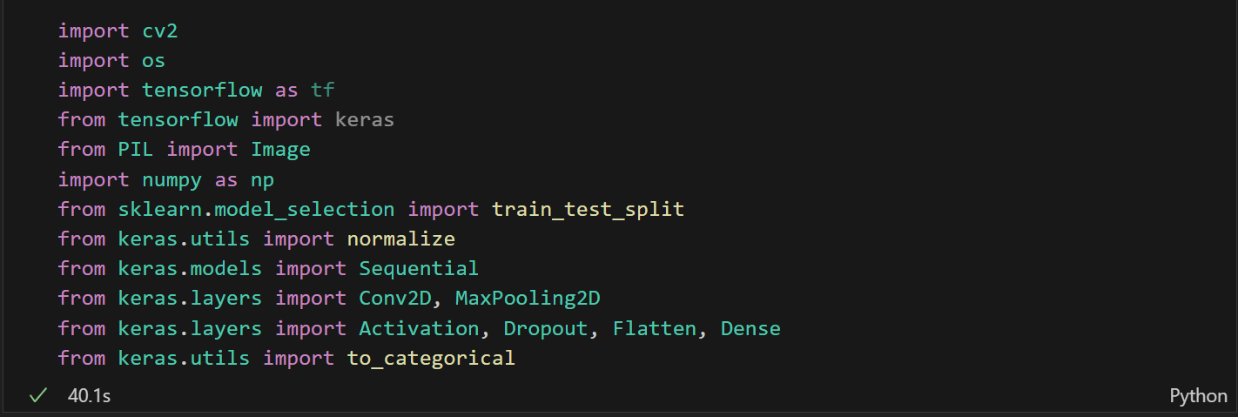

**Step 2: Processing dataset for images related to tumors:**

This line defines a variable image_directory and sets it to the string 'datasets/'.Two empty lists, dataset and label, are initialized. These lists will be used to store image data and corresponding labels.

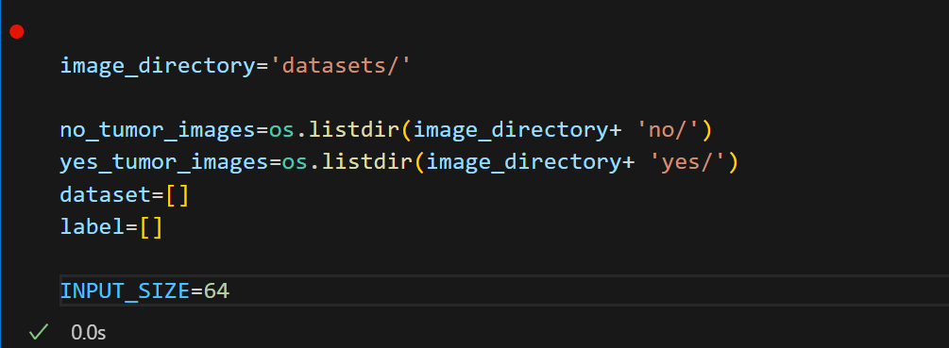

**Step 3: Configuring, training, and saving a neural network model:**

In this step we compiles a neural network model for binary classification using categorical cross-entropy loss, trains it on the provided data, and saves the trained model to a file.

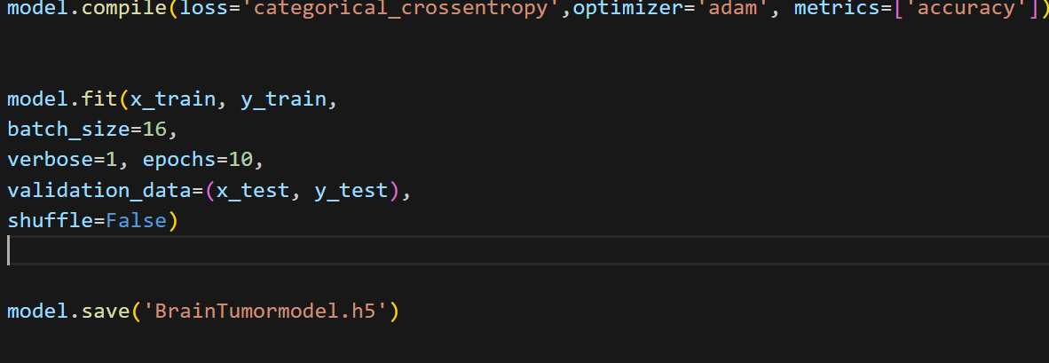

**Step 4: Load our trained neural network model:**

In this step we loads our trained model, processes an image for prediction, and then uses the loaded model to predict probabilities for the input image.

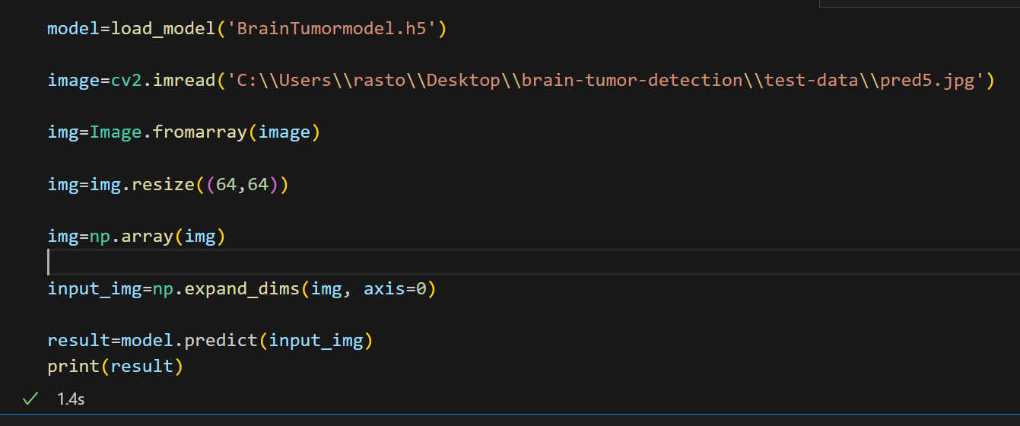

**Step 5: Setting up a Flask web application for predicting brain tumor**

**presence:**

The trained neural network model ('BrainTumormodel.h5') is loaded using the load_model function. A message is printed to the console indicating that the model has been loaded.

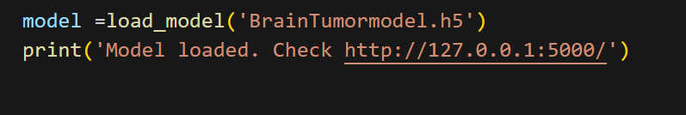

**Step 6: Defining a function to get predictions for an image:**

In this step, a function processes an image and returns the prediction result using the trained model.

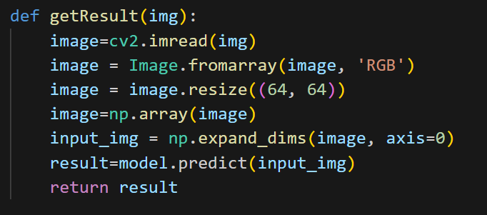

**Step 7: Run the Flask app:**

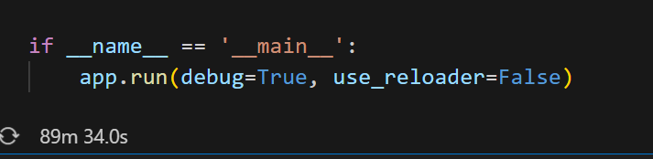

Now this Flask app provides a simple web interface where users can upload an image,and the pre-trained model is used to predict whether the image contains a brain tumor or not.

**Step 8: Used Gradio to create a deployable app with UI:**

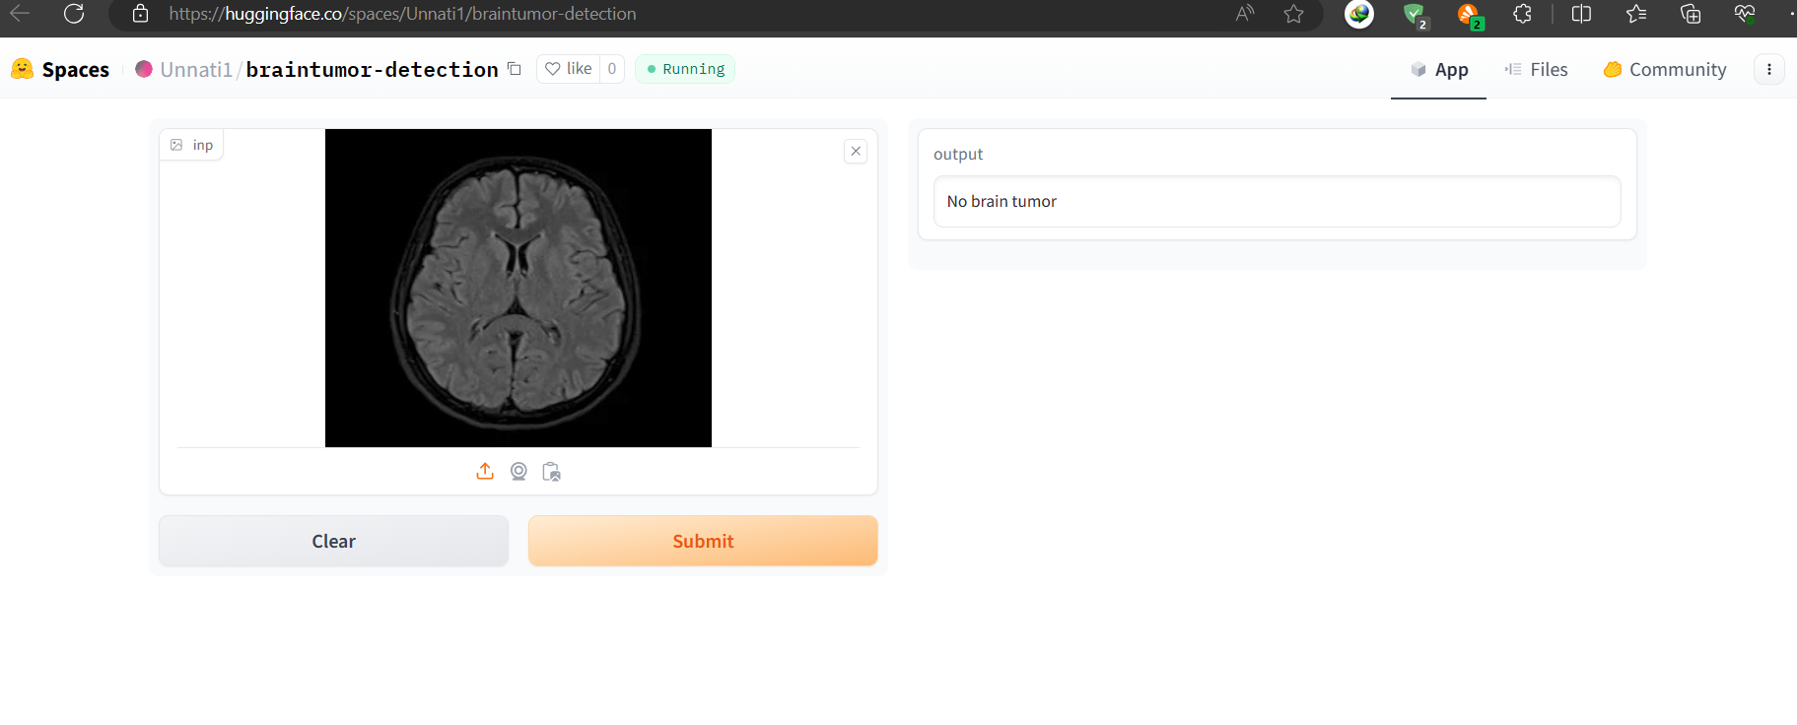

In this step we used gradio which is a python library to develop a interactive User Interface for our project. We also deployed our project on hugging face.

App Link : [Braintumor Detection - a Hugging Face Space by Unnati1](https://huggingface.co/spaces/Unnati1/braintumor-detection)

**Chapter 4**

**RESULT AND DISCUSSION**

**4.1 RESULT**

* The deep learning model analyzed the provided medical image and predicted the presence or absence of a brain tumor.

Predicted Class: [Predicted Class, e.g., “Yes Brain Tumor" or "No Brain Tumor "]

Accuracy score: 85.67%

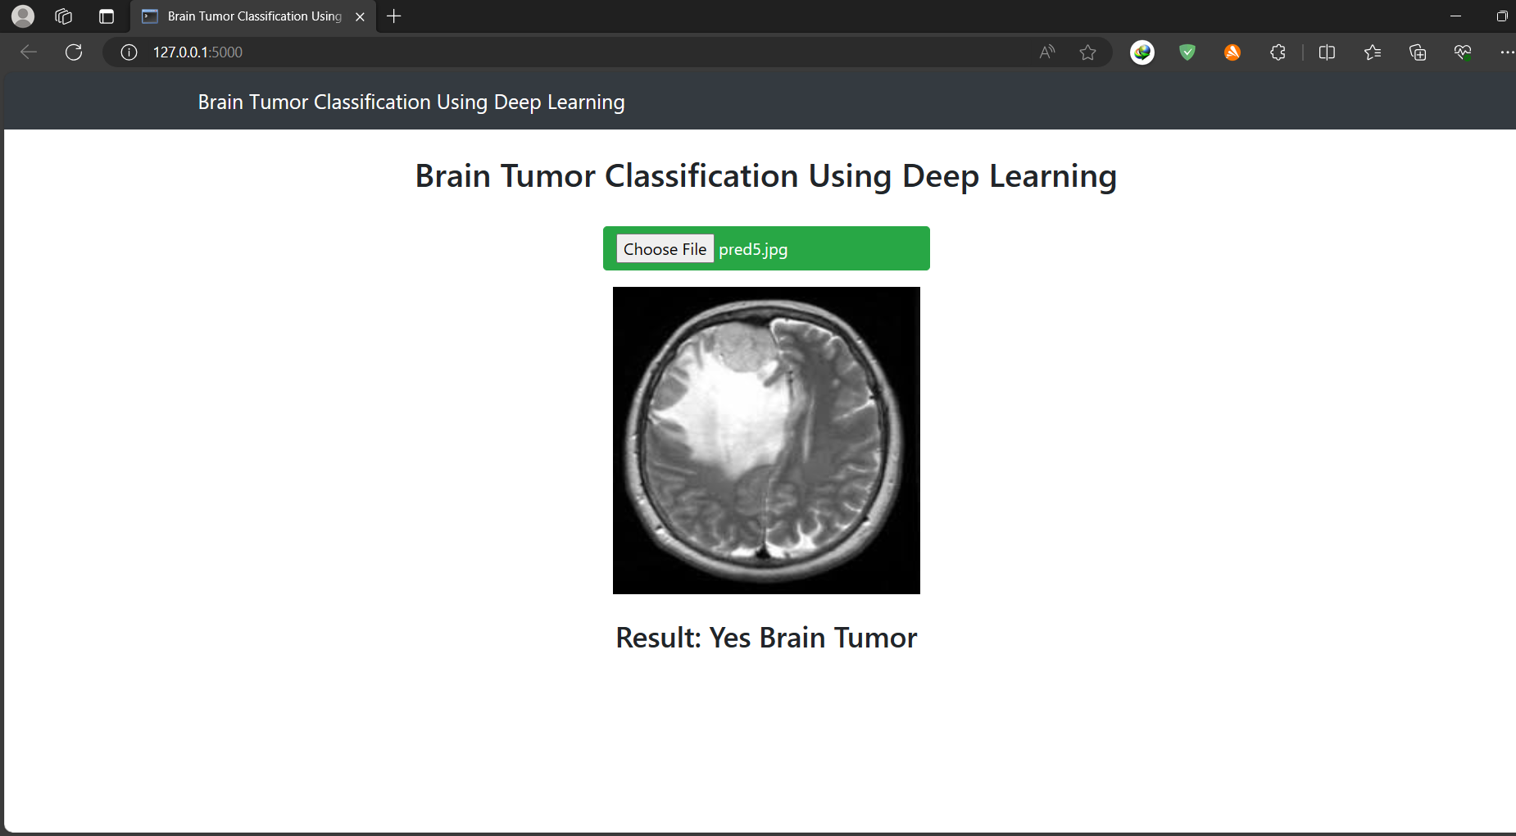

* As a result of this, the system can be said to perform and predict the desired result as per requirement and with ample enough accuracy and precision. Also the deployed link for the project is provided.
* This also became a great opportunity for learning various concepts and technologies related to the field of Image Classification in Healthcare and machine learning in general.

**Chapter 5**

**CONCLUSION AND FUTURE WORK**

**5.1 CONCLUSION**

In summary, the brain tumor detection project, which uses advanced learning methods, has shown really good results. The model, taught on lots of different pictures, proved it can correctly sort medical images into "No Brain Tumor" and "Brain Tumor Detected." Bringing this technology into healthcare helps doctors quickly check brain images.

The project worked well, showing that artificial intelligence can make diagnostic processes better. The model is easy to understand, and because it's so accurate, it's a helpful tool for doctors to make smart choices.

**Future Work:**

This project is like a starting point for making things better and doing more in the future.

1. Increased Dataset Diversity:

Making the collection of pictures bigger by including images from more types of

people, different ways of taking pictures, and various health conditions. Fixing the

issue where there are not enough examples of some cases in the pictures, so the

computer can make fair predictions.

1. Clinical Integration:

Working together with doctors and nurses to check if the computer predictions are

right in real-time and getting feedback. Doing studies in advance to see how using

the computer program affects patients and the way healthcare tasks are done.

3. Global Collaboration:

Working with healthcare organizations around the world to gather lots of different

pictures that show a wide range of situations. Also, sharing knowledge and tools

openly so everyone can get better at understanding medical images.

**References**

1. Sultan H.H., Salem N.M., Al-Atabany W. Multi-classification of brain tumor images using deep neural network. *IEEE Access.*2019;7:69215–69225. [[Google Scholar](https://scholar.google.com/scholar_lookup?journal=IEEE+Access&title=Multi-classification+of+brain+tumor+images+using+deep+neural+network&author=H.H.+Sultan&author=N.M.+Salem&author=W.+Al-Atabany&volume=7&publication_year=2019&pages=69215-69225&)]
2. Muhammad Arif F., Ajesh Shermin Shamsudheen, Geman Oana, Izdrui Diana, Vicoveanu Dragos. Brain tumor detection and classification by mri using biologically inspired orthogonal wavelet transform and deep learning techniques. *J Healthcare Eng.*2022 [[PMC free article](https://www.ncbi.nlm.nih.gov/pmc/articles/PMC8763556/)] [[PubMed](https://pubmed.ncbi.nlm.nih.gov/35047149)] [[Google Scholar](https://scholar.google.com/scholar_lookup?journal=J+Healthcare+Eng&title=Brain+tumor+detection+and+classification+by+mri+using+biologically+inspired+orthogonal+wavelet+transform+and+deep+learning+techniques&author=F.+Muhammad+Arif&author=Shermin+Shamsudheen+Ajesh&author=Oana+Geman&author=Diana+Izdrui&author=Dragos+Vicoveanu&publication_year=2022&)] [Retracted](https://www.ncbi.nlm.nih.gov/pmc/articles/PMC10232141/)

3. Behin A., Hoang-Xuan K., Carpentier A.F., Delattre J.-Y. Primary brain tumours in

adults. *Lancet.*2003;361(9354):323–331. [[PubMed](https://pubmed.ncbi.nlm.nih.gov/12559880)] [[Google Scholar](https://scholar.google.com/scholar_lookup?journal=Lancet&title=Primary+brain+tumours+in+adults&author=A.+Behin&author=K.+Hoang-Xuan&author=A.F.+Carpentier&author=J.-Y.+Delattre&volume=361&issue=9354&publication_year=2003&pages=323-331&pmid=12559880&)]

4. [Brain MRI Images for Brain Tumor Detection (kaggle.com)](https://www.kaggle.com/datasets/navoneel/brain-mri-images-for-brain-tumor-detection)

5. [Image classification  |  TensorFlow Core](https://www.tensorflow.org/tutorials/images/classification)

6. [Image Classification In Tensorflow (gradio.app)](https://www.gradio.app/guides/image-classification-in-tensorflow)